Report
Team ID | MCA
Project Name | Smartphone Usage, Digital Addiction & Well-Being Analytics
Maximum Marks | 5 Marks
A report is a comprehensive document that provides a detailed and structured account of data analysis, findings, and insights. It is typically used for in-depth analysis, documentation, and communication of results. Reports are suitable for a diverse audience, including decision-makers, analysts, and stakeholders who need a comprehensive understanding of the data.
Designing a report in Power BI involves connecting to data sources, creating visualizations like charts and graphs, customizing their appearance and interactivity, organizing them logically on the canvas, formatting elements for consistency and clarity, and optionally creating dashboards for a summarized view. Throughout the process, it's essential to consider the audience's needs and ensure the report effectively communicates insights from the data. Finally, iterate based on feedback to continually improve the report's design and usefulness.

Report – 1
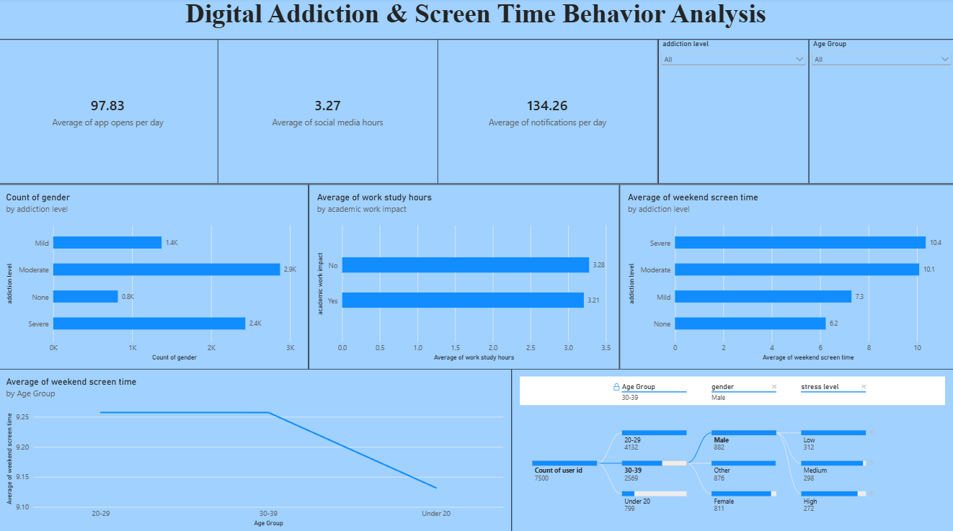
Observations drawn from reports in Power BI can provide valuable insights into business performance and trends.
1. Trends Over Time
- Analyze how key metrics (e.g., sales, revenue, or customer counts) change over different time periods (monthly, quarterly, annually) to identify growth patterns or seasonality.
2. Performance Comparisons
- Compare performance across different categories, such as regions, products, or departments, to determine which areas are excelling or underperforming.
3. Customer Segmentation
- Assess demographic data (age, gender, location) to understand customer segments and tailor marketing strategies accordingly.
4. Goal Achievement
- Measure progress against established KPIs (Key Performance Indicators) to assess whether business goals are being met.
Example Findings:
- Core Digital Engagement: Users interact heavily with their devices on a daily basis, logging a baseline average of 97.83 app opens per day alongside an average of 134.26 notifications received per day and 3.27 average social media hours.
- Prevalence of Addiction Levels: When evaluating the user base by categorical metrics, the Moderate group forms the largest share with 2,874 users, followed closely by the Severe group with 2,434 users out of the tracked gender counts.
- Weekend Screen-Time Escalation: Users categorized with a Severe addiction level reach the highest weekend smartphone usage at an average of 10.4 hours, compared to 6.2 hours for those with no behavioral addiction, showing a direct upward trend as addiction level rises.
- Demographic Breakdown Path: Out of 7,500 total tracked users split through the decomposition tree, the largest segment is the 20–29 age group (4,132 users), within which Males represent 882 users, Other represents 876 users, and Females represent 211 users when filtering specific structural nodes.

Report – 2
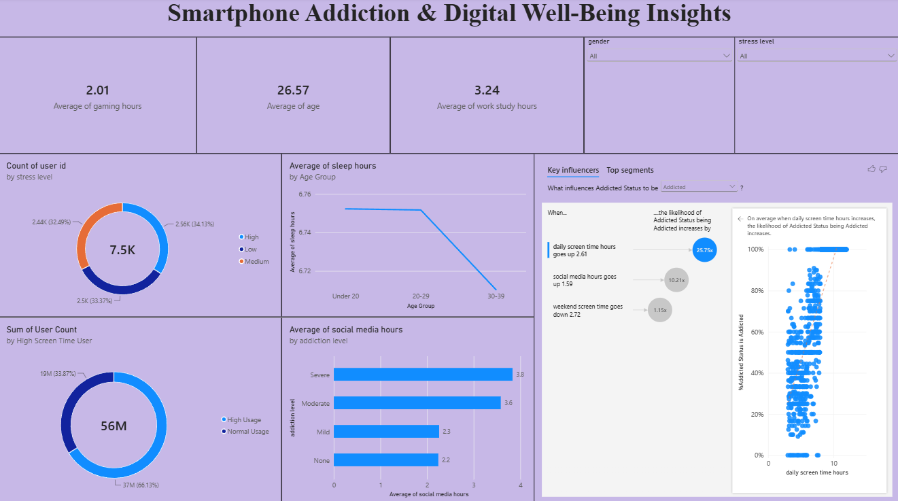
Observations drawn from reports in Power BI can provide valuable insights into business performance and trends.
1. Trends Over Time
- Analyze how key metrics (e.g., sales, revenue, or customer counts) change over different time periods (monthly, quarterly, annually) to identify growth patterns or seasonality.
2. Performance Comparisons
- Compare performance across different categories, such as regions, products, or departments, to determine which areas are excelling or underperforming.
3. Customer Segmentation
- Assess demographic data (age, gender, location) to understand customer segments and tailor marketing strategies accordingly.
4. Goal Achievement
- Measure progress against established KPIs (Key Performance Indicators) to assess whether business goals are being met.
Example Findings:
- Stress Level Distribution: The user base exhibits a relatively even breakdown across categories, where the High stress level cohort slightly leads the study at 34.13% (2.56K users) out of a total 7.5K population.
- Sleep Deficit Trends: Rest cycles drop consistently based on demographic brackets, with the 30–39 age group experiencing the lowest average rest profile at roughly 6.71 sleep hours compared to the higher rest benchmarks of younger cohorts.
- Social Media Dependency: Users labeled with a Severe addiction level display the highest engagement metrics, logging nearly 4 hours (3.8 hours) of average social media platform runtime, contrasting with the 2.2 hours logged by non-addicted users.
- Key Behavioural Drivers (AI Insights): The Key Influencers analysis proves that a user's likelihood of being classified as addicted increases drastically by 25.75x when their daily screen time scales upward by 2.61 hours, while rising social media hours by 1.59 further triggers the condition.

